

Bangladesh Army University of Science and Technology
Saidpur, Nilphamari

Project Title: CV Builder System

SESSIONAL PROJECT REPORT

CSE 2108
Object Oriented Programming Language II Sessional

Submitted By

Student Name | Student ID
- Md.Al-Maynul Hasan | 0802420205101025
- Md.Asif Hasan | 0802420205101032
- Md.Maruf Siddiki | 0802420205101034

Date: 25 November 25

Submitted To:

Course Teacher’s Name
Designation
Department of Computer Science and Engineering
Bangladesh Army University of Science and Technology

Course Teacher’s Name
Designation
Department of Computer Science and Engineering
Bangladesh Army University of Science and Technology

The complete source code of this project is available at the following GitHub repository: https://github.com/AlMaynulHasan

Table of Contents

Introduction 1
1.1 Introduction 1
1.2 Objectives 1
1.3 Project Outcome 2
System Analysis & Design 2
2.1 Requirement Analysis & Design Specification 3
2.2 Overall Project Plan 5
Implementation and Results 3
3.1 UI Design 6
3.2 Workflow of Application 8
3.3 Code Snippets (key parts only: login module, event handling, database connection) 8
3.4 Results and Discussion 10
Conclusion 4
References 5

Chapter 1

Introduction

Introduction
System is a desktop application developed using Java Swing that enables users to efficiently create, manage, and export professional Curriculum Vitae (CV). The system features a multi-tab interface, allowing users to input personal information, educational qualifications, work experience, skills, and project details in an organized manner. Additionally, the application provides an Admin Dashboard, which allows administrators to efficiently manage all user CVs. The dashboard displays a table view of CVs, including details such as name, email, CGPA, total experience, skills, and projects. Administrators can sort CVs by name, experience, or CGPA, open individual CVs for review, and export selected CVs as PDF files.
The CV Builder System is developed using Java Swing, which provides the graphical user interface (GUI) components such as JFrame, JPanel, JTabbedPane, JButton, JTable, and JList to create a user-friendly and interactive interface. For data management, the system uses the Gson library to serialize and deserialize CV information into JSON format, enabling efficient saving and retrieval of user data from the cv_data.json file. To generate professional and printable CVs, the application employs iText (com.lowagie.text) for PDF export functionality. Additionally, Java AWT is used for event handling, layouts, and input validation, while standard file handling techniques manage reading and writing of CV files to the local storage. Together, these technologies provide a standalone, lightweight, and fully functional desktop solution for CV creation and management.
The CV Builder System serves students, job seekers, and interns by helping them create structured CVs, while administrators or HR personnel can efficiently manage and export multiple CVs through the Admin Dashboard. The system is scalable, storing all CVs in a centralized JSON file for easy sorting, review, and management.

Objectives
- To develop a user-friendly platform for creating professional CVs using Java Swing.
- To allow users to input and organize personal, educational, and professional information efficiently.
- To store CVs in JSON format for easy retrieval, editing, and management.
- To provide PDF export functionality for generating printable and professional CVs.
- To implement an Admin Dashboard for managing all CVs with sorting and searching capabilities.
- To enable administrators to view, open, and export selected CVs for assessment purposes.
- To maintain a clean and intuitive UI, using components such as JFrame, JPanel, JTabbedPane, JTable, JButton, and JList.

Project Outcome
Upon completion, the CV Builder System provides the following outcomes:

- Users can create, edit, and save multiple CVs in a structured format.
- All CV data is securely stored in a JSON file (cv_data.json).
- Users can generate professional PDF files of their CVs with a single click.
- The Admin Dashboard allows administrators to:
- View a complete list of CVs with details such as name, email, CGPA, experience, skills, and projects.
- Sort CVs based on Name, CGPA, or Experience for easy comparison.
- Open any CV to view or edit its contents.
- Export selected CVs as PDF for sharing or evaluation.
- The system provides a streamlined workflow, reducing the time and effort required for CV creation and management.
- The application lays the groundwork for future enhancements, such as database integration, user authentication, and multiple CV templates.
Chapter 2

System Analysis & Design

Requirement Analysis & Design Specification

Overview
The CV Builder System is designed to provide a user-friendly and efficient solution for creating, managing, and exporting professional Curriculum Vitae (CV). The system captures essential user data, including personal information, education, work experience, skills, and projects, and stores it in a centralized JSON file for easy access and modification.
Key functional requirements of the system include:
- Ability to create, edit, and save CVs for multiple users.
- PDF generation for professional resumes using iText.
- Admin Dashboard to view, sort, and export CVs.
- Input validation for required fields like name and email.
- Scalable architecture to handle any number of CV entries.
Key non-functional requirements include:
- Performance: Fast response time when saving and loading CVs.
- Usability: Intuitive GUI using Java Swing components like JFrame, JPanel, JTabbedPane, JButton, and JTable.
- Reliability: Stable data storage using JSON files.
- Maintainability: Modular code structure separating GUI, data management, validation, and PDF export functionality.

Project Development Methodology Flowchart

The CV Builder project follows a structured software development methodology, combining elements of Waterfall and Iterative approaches for planning, designing, implementing, and testing the CV Builder System.

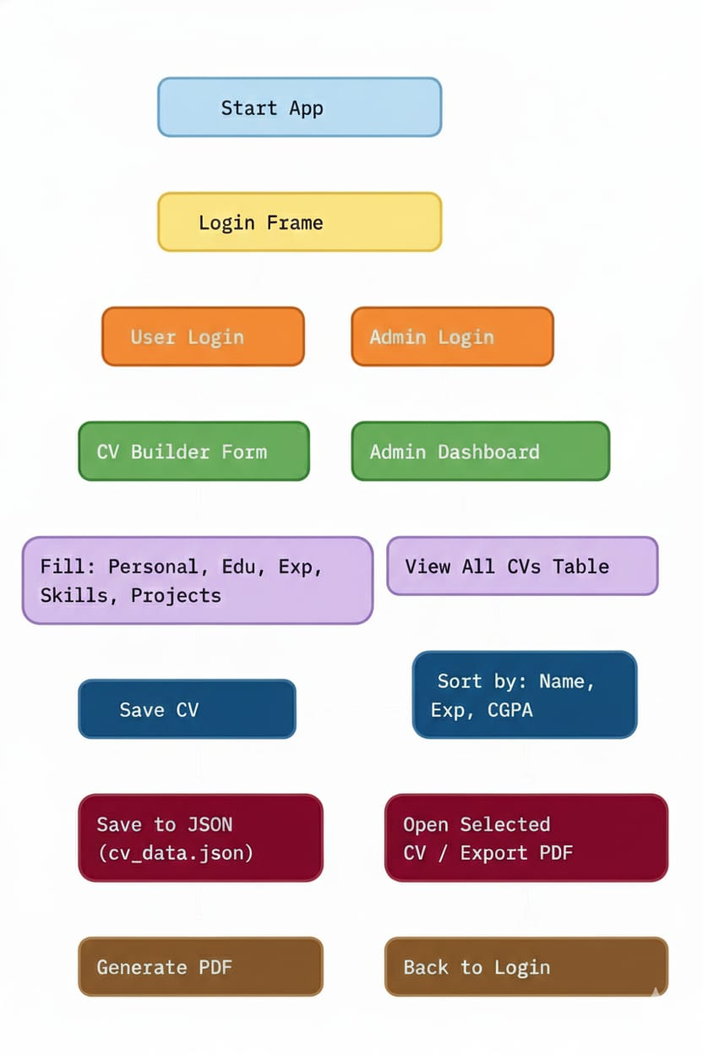
Figure 2.1: Methodology Flowchart of CV Builder desktop application

Overall Project Plan

Phase | Tasks / Activities | Estimated Duration
Requirement Analysis | Collect system requirements from potential users- Identify functional and non-functional specifications | 1 week
System Design | Design GUI for user CV input and Admin Dashboard- Define data storage structure using JSON files- Create flowcharts and design diagrams | 1 week
Implementation | Develop modules for Login, CV Builder Form, Admin Dashboard, JSON handling, and PDF export- Integrate validation, event handling, and sorting features | 2–3 weeks
Testing | Test all functionalities including input validation, data storage, CV loading, and PDF generation- Fix bugs and improve performance | 1 week
Deployment & Maintenance | Package the application for desktop use- Provide documentation and guidelines for future enhancements | 1 week

Chapter 3

Implementation and Results

UI Design
The CV Builder System uses a Java Swing–based GUI to provide a user-friendly interface for CV creation and management. The application consists of multiple screens and components:
- JFrame: The main window container for all screens, including the Login screen, CV Builder Form, and Admin Dashboard.
- JPanel: Used to organize and group related components such as personal information, education, experience, skills, and projects. Each tab in the CV Builder Form is a separate JPanel.
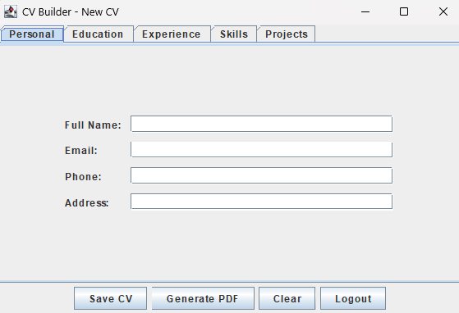
- JTabbedPane: Provides a tabbed interface for different sections of the CV (Personal, Education, Experience, Skills, Projects), allowing smooth navigation.
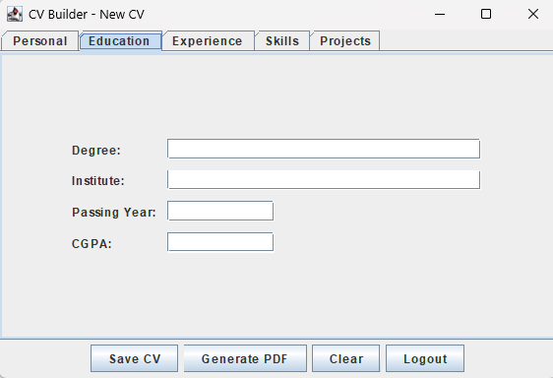
- JButton: Interactive buttons such as Save CV, Generate PDF, Add Skill, Add Project, and Logout. Each button is linked with event handling to perform specific actions.
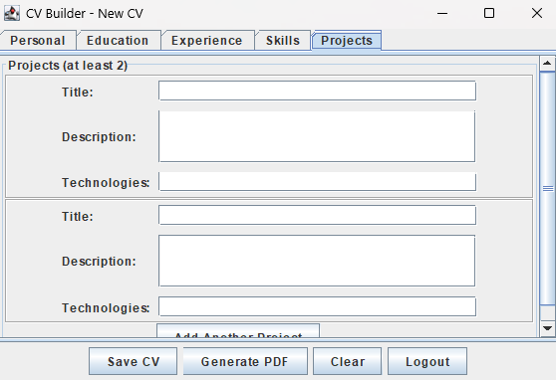
- JTable: Displays all saved CVs in the Admin Dashboard, supporting sorting and selection.
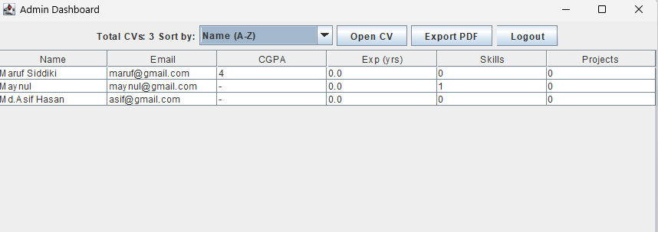
- JList: Displays a list of skills added by the user in the Skills tab.
- JTextField / JTextArea: Input fields for entering personal details, education, experience, and project descriptions.
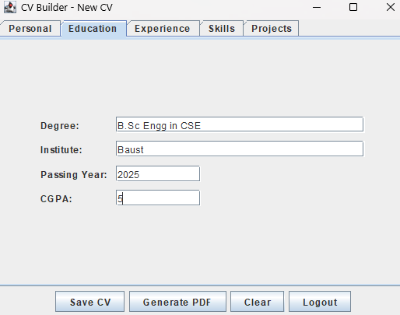

Workflow of Application
The CV Builder System follows this workflow:
- Login Screen: Users select either User Login or Admin Login.
- User Login: Opens the CV Builder Form where users can create or edit CVs.
- Admin Login: Accesses the Admin Dashboard after entering the correct password, allowing viewing, sorting, and exporting CVs.
- CV Builder Form: Users enter personal details, education, work experience, skills, and projects across multiple tabs.
- Save CV: Data is validated and stored in cv_data.json.
- Generate PDF: The CV is exported as a professional PDF using iText.
- Admin Dashboard: Administrators can select any CV to view details or export PDF, with sorting options by Name, CGPA, or Experience.

Code Snippets (key parts only: login module, event handling, database connection)

Code: Login Module

JButton userBtn = new JButton("User Login");

userBtn.addActionListener(e -> {

dispose();

new CVBuilderForm(null);

});

JButton adminBtn = new JButton("Admin Login");

adminBtn.addActionListener(e -> {

String pass = JOptionPane.showInputDialog(this, "Enter Admin Password:");

if ("admin123".equals(pass)) {

dispose();

new AdminDashboard();

} else if (pass != null) {

JOptionPane.showMessageDialog(this, "Wrong password!", "Error", JOptionPane.ERROR_MESSAGE);

}

});

Code: Save CV Button

btnSave.addActionListener(e -> {

if (validateForm()) {

saveCV();

JOptionPane.showMessageDialog(this, "CV Saved Successfully!");

}

});

Code: JSON Data Handling

static List<CV> loadCVs() {

try {

if (!Files.exists(Paths.get(CV_FILE))) return new ArrayList<>();

String json = Files.readString(Paths.get(CV_FILE));

return gson.fromJson(json, new TypeToken<List<CV>>(){}.getType());

} catch (Exception e) {

return new ArrayList<>();

}

}

static void saveCVs(List<CV> list) {

try {

Files.writeString(Paths.get(CV_FILE), gson.toJson(list));

} catch (Exception e) { e.printStackTrace(); }

}

Code: PDF Export Example:

Document doc = new Document(PageSize.A4);

PdfWriter.getInstance(doc, new FileOutputStream(fc.getSelectedFile()));

doc.open();

doc.add(new Paragraph("Name: " + cv.fullName));

doc.add(new Paragraph("Email: " + cv.email));

doc.close();

Results and Discussion
The implementation of the CV Builder System successfully demonstrates a complete solution for creating, managing, and exporting professional CVs. Users can enter detailed information across multiple sections, including personal details, education, work experience, skills, and projects, ensuring a structured and organized resume. All CV data is securely stored in a centralized JSON file, enabling persistent storage and easy retrieval for future editing. The system also allows users to generate professional PDF versions of their CVs, providing a clean and standardized output suitable for job applications or internships. The Admin Dashboard adds significant value by allowing administrators or HR personnel to view all stored CVs, sort them by name, experience, or CGPA, and export selected CVs as PDFs. Input validation ensures that critical fields, such as name and email, are correctly filled, reducing errors and maintaining data integrity. Overall, the system achieves its objectives of being user-friendly, efficient, and scalable, making CV creation and management simple and reliable. While the current implementation is desktop-based with local JSON storage, future enhancements could include database integration for multi-user remote access, additional CV templates, and advanced reporting features in the Admin Dashboard. These improvements would further increase the system’s usability and flexibility for a larger user base.

Chapter 4

Conclusion

The CV Builder System is a comprehensive desktop application that provides an efficient solution for creating, managing, and exporting professional Curriculum Vitae (CV). By using a multi-tabbed interface, users can input personal information, educational background, work experience, skills, and project details in a structured and organized manner. The system ensures accuracy and consistency of data through input validation and centralized JSON storage.The inclusion of the Admin Dashboard allows administrators and HR personnel to manage multiple CVs effectively, offering features like sorting, viewing, and exporting CVs as PDF documents. The PDF export functionality generates clean and professional resumes, which are suitable for academic, internship, or job applications.Overall, the project achieves its main objectives of ease-of-use, scalability, and reliability. It demonstrates how Java Swing, Gson, and iText can be combined to create a lightweight and fully functional desktop application.
Limitations
- The system is desktop-based, limiting access to a single machine and not supporting multi-user collaboration over a network.
- CV templates are fixed, offering limited customization for styling, formatting, and layout.
- No cloud backup or online storage, so data is dependent on local JSON files.
- The system does not include advanced input validation for fields such as phone numbers or dates beyond basic checks.
- Project and experience sections allow only basic text input; rich media or attachments are not supported.
- No authentication system for multiple users; all user CVs are stored in a single JSON file, which could lead to data management issues in larger deployments.
Future Extensions
- Database Integration: Connect to a remote database to allow multi-user access, cloud storage, and better data management.
- Multiple CV Templates: Provide various CV layouts and styling options to let users customize the appearance of their resumes.
- Rich Media Support: Allow users to attach images, certificates to their CVs.
- Analytics & Reporting: Include features to generate reports on user skills, experience levels, and CV statistics.
- Export Formats: Provide additional export options like DOCX, HTML, or LaTeX in addition to PDF.
- Multi-language Support: Allow users to create CVs in different languages for global applications.
- Integration with Job Portals: Provide features to directly submit CVs to online job portals or recruitment platforms.

References

[1] Jon Kleinberg and Eva Tardos. Algorithm design. Pearson Education India, 2007.
[2] Oracle. Java Platform, Standard Edition Documentation. https://docs.oracle.com/javase/ Accessed: 25 November 2025, 00:10.
[3] Google Gson Library Documentation. https://github.com/google/gson Accessed: 25 November 2025, 00:12.
[4] iText (com.lowagie.text) API Documentation. https://itextpdf.com/en/resources/api Accessed: 25 November 2025, 00:15.
[5] Oracle. Java Swing Tutorial. https://docs.oracle.com/javase/tutorial/uiswing/ Accessed: 25 November 2025, 00:18.
[6] Kathy Walrath and Mary Campione. The JFC Swing Tutorial: A Guide to Constructing GUIs (2nd Edition). Addison-Wesley, 1999.

